//Dijkstra's Algorithm
#include<stdio.h>
#include<conio.h>
#define INFINITY 9999
#define MAX 10

void dijikstra(int G[MAX][MAX], int n, int startnode);

void main(){
int G[MAX][MAX], i, j, n, u;
system("cls");
printf("\nEnter the no. of vertices:: ");
scanf("%d", &n);
printf("\nEnter the adjacency matrix::\n");
for(i=0;i < n;i++)
for(j=0;j < n;j++)
scanf("%d", &G[i][j]);
printf("\nEnter the starting node:: ");
scanf("%d", &u);
dijikstra(G,n,u);
getch();
}

void dijikstra(int G[MAX][MAX], int n, int startnode)
{
int cost[MAX][MAX], distance[MAX], pred[MAX];
int visited[MAX], count, mindistance, nextnode, i,j;
for(i=0;i < n;i++)
for(j=0;j < n;j++)
if(G[i][j]==0)
cost[i][j]=INFINITY;
else
cost[i][j]=G[i][j];

for(i=0;i< n;i++)
{
distance[i]=cost[startnode][i];
pred[i]=startnode;
visited[i]=0;
}
distance[startnode]=0;
visited[startnode]=1;
count=1;
while(count < n-1){
mindistance=INFINITY;
for(i=0;i < n;i++)
if(distance[i] < mindistance&&!visited[i])
{
mindistance=distance[i];
nextnode=i;
}
visited[nextnode]=1;
for(i=0;i < n;i++)
if(!visited[i])
if(mindistance+cost[nextnode][i] < distance[i])
{
distance[i]=mindistance+cost[nextnode][i];
pred[i]=nextnode;
}
count++;
}

for(i=0;i < n;i++)
if(i!=startnode)
{
printf("\nDistance of %d = %d", i, distance[i]);
printf("\nPath = %d", i);
j=i;
do
{
j=pred[j];
printf(" <-%d", j);
}
while(j!=startnode);
}
}
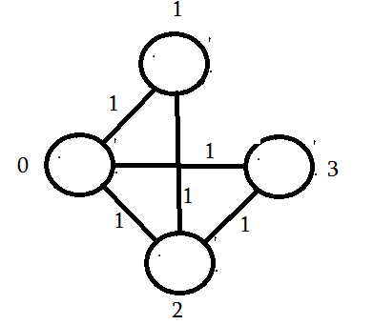

Enter the number of vertices:
4

Enter the adjacency matrix:
0
1
1
1
1
0
1
0
1
1
0
1
1
0
1
0

Enter the starting node:
1

Distance of 0 = 1
Path = 0<-1
Distance of 2 = 1
Path = 2<-1
Distance of 3 = 2
Path = 3<-0<-1

